AI-Augmented Backend Development Project
TITLE:
AI BlogNest API – AI-Powered Blog Content Management System
Project Description
AI BlogNest API is an AI-Augmented backend web application developed using MongoDB, Express.js, and Node.js, integrated with Artificial Intelligence capabilities using Google Gemini AI. The system is designed to simplify blog creation, content management, and AI-assisted writing. It provides secure REST APIs for user authentication, blog management, comments, categories, and content operations. The application uses JWT authentication and role-based access control to protect resources. AI capabilities such as AI-powered blog content generation and content summarization help users create high-quality, context-aware blog content efficiently. The system combines traditional backend development with modern AI technologies to provide a secure, scalable, and intelligent content management platform.
Scenario
Problem:
Blog creators often spend significant time planning, writing, organizing, and managing blog content. Managing multiple drafts, categories, tags, comments, and publishing activities manually can become difficult as the number of blog posts increases. Traditional content management systems also require users to create most of the content manually, which can make the overall blogging process time-consuming and less efficient.
solution:
AI BlogNest API addresses these problems by integrating Artificial Intelligence with a secure backend system. Google Gemini AI is used to assist users with AI-powered blog content generation and content summarization. The application provides REST APIs for
creating and managing blogs while JWT authentication and role-based access control protect the system. AI assistance reduces manual effort and helps users generate and process content more efficiently.
Impact:
AI BlogNest benefits content creators, authors, editors, administrators, and readers by providing a centralized platform for blog management and AI-assisted content creation. Authors can create and manage blog posts, editors can review and manage content, administrators can control users and system activities, and readers can access published blogs. The application improves the efficiency of content creation while maintaining security, organization, and scalability.
System Requirements
To ensure smooth development, deployment, and usage of the AI BlogNest API AI Augmented Backend Application, certain system prerequisites must be met.
1. Software Requirements
Operating System
Windows 10/11
macOS
Linux
Node.js (v16 or above)
Provides the runtime environment required for backend development and execution. npm (v8 or above)
Package manager used for installing and managing project dependencies. Express.js
Backend framework used for developing REST APIs and handling server-side requests. MongoDB
NoSQL database used to store:
User Information
Blog Posts
Categories
Comments
Analytics Data
Mongoose
ODM used for defining database schemas, validating data, and interacting with MongoDB.
Google Gemini AI
AI service used for:
AI-powered blog content generation
Content summarization
AI-assisted content creation
Postman / Thunder Client
API testing tools used to test and verify the REST API endpoints. Visual Studio Code
Development environment used for writing, editing, and managing the AI BlogNest backend project.
Git and GitHub
Used for source-code version control and project management. Environment Variables
Used to securely store sensitive configuration values such as:
MongoDB connection string
JWT secret
Gemini API key
2. HARDWARE REQUIREMENTS
Processor
Intel Core i5 (8th Generation or above) / AMD Ryzen 5 or equivalent. RAM
Minimum 8 GB
Recommended 16 GB
Storage
Minimum 1 GB free project workspace.
Internet Connection
Required for package installation, database connectivity, and Google Gemini AI API communication.
Display
1366 × 768 or above.
3. PROJECT ARCHITECTURE
Technical Architecture
AI BlogNest follows a modular layered backend architecture using Node.js, Express.js, MongoDB, JWT authentication, and Google Gemini AI.
Backend Layer
Node.js
Express.js
REST APIs
JWT Authentication
Role-Based Authorization
Database Layer
MongoDB
Mongoose ODM
Users
Posts
Categories
Comments
Analytics Data
AI Layer
Google Gemini AI
AI Blog Generation
Content Summarization
Prompt-Based Content Generation
Security Layer
JWT Authentication
Protected Routes
Password Hashing
Input Validation
Input Sanitization
Rate Limiting
Role-Based Access Control
Architecture Diagram
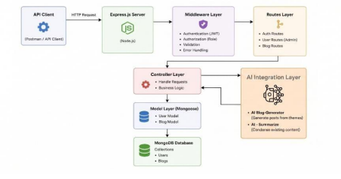Categories
Caption:
Figure 1: AI BlogNest API Technical Architecture
4. ER DIAGRAM
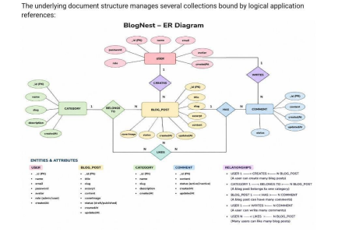
Users
_id
name
email
password
role
Posts
_id
userID
name
photo
message
likes
createdAt
updatedAt
Comments
_id
postId
userId
comment
status
createdAt
Categories
_id
name
description
Analytics
Stores information related to blog activity and performance where implemented. ER Diagram Explanation
Users can create and manage blog posts based on their assigned role. A single user can create multiple posts, while a blog post can contain multiple comments. Comments are associated with users and posts. Categories and tags help organize blog content and improve content discoverability.
ER Diagram
Diagram:
USER
|
| 1 : Many
↓
POST
|
| 1 : Many
↓
COMMENT
POST -------- CATEGORY
Caption:
Figure 2: AI BlogNest API Entity Relationship Diagram 5. FEATURES
Core Backend Features
User Registration
User Login
JWT Authentication
Protected Routes
Role-Based Access Control
Blog CRUD Operations
Draft Management
Publishing Status
Categories and Tags
Comment Management
Comment Moderation
Media Metadata Management
Input Validation
Input Sanitization
Rate Limiting
Structured Logging
AI Features
AI-Powered Blog Generation
Content Summarization
AI-Assisted Content Creation
Context-Aware Content Generation
The AI BlogNest reference specifically describes Gemini AI integration for AI-powered blog generation and content summarization. �
AI BlogNest API.docx
6. ROLES AND RESPONSIBILITIES
Admin
Manage users
Change user roles
Manage comments
Monitor system activities
Inspect logging information
Editor
Review draft posts
Approve posts
Publish posts
Manage categories
Author
Create blog posts
Manage their own posts
Prepare draft content
Reader
Read published blogs
Create comments
Access public content
AI BlogNest API.docx
7. USER FLOW
User Registration
User Login
JWT Authentication
Role Verification
Access Protected APIs
Create Blog
Store Blog in MongoDB
Generate AI Content if required Review Blog
Publish Blog
Reader Views Published Blog Reader Adds Comment
Registration
↓
Login
↓
JWT Authentication
↓
Role Verification
↓
Create / Manage Blog
↓
MongoDB
↓
AI Content Generation
↓
Review / Publish
↓
Reader
↓
Comments
Caption:
Figure 3: AI BlogNest API User Flow
8. MVC PATTERN
The AI BlogNest backend follows the MVC (Model-View-Controller) architecture pattern. Model Layer
Responsible for:
User Schema
Post Schema
Comment Schema
Category Schema
Database Validation
Implemented using Mongoose.
Controller Layer
Responsible for:
Authentication Logic
Blog CRUD Operations
Comment Operations
AI API Integration
Content Generation
Content Summarization
Request Processing
View Layer – API Routes
Since AI BlogNest is a headless backend application, traditional frontend views are not used. API routes act as the interface between client requests and controllers.
Authentication Routes
Register
Login
Blog Routes
Create
Read
Update
Delete
Comment Routes
Create Comment
Manage Comments
AI Routes
Generate Blog
Summarize Content
Advantages of MVC
Separation of Concerns
Better Maintainability
Easy Scalability
Reusable Components
Easier Testing
The reference AI BlogNest document describes the same headless API routing approach for its MVC structure. �
AI BlogNest API.docx
Routes
↓
Controllers
↙ ↘
Models AI Service
↓ ↓
MongoDB Gemini AI
Caption:
Figure 4: MVC Architecture of AI BlogNest API
9. PROJECT SETUP AND CONFIGURATION
Project Structure
Create a project folder named:
AI-BlogNest
Inside the project:
Server
Open the Server folder in Visual Studio Code.
Server Setup
mkdir server
cd server
npm init -y
Create:
server.js
Create folders:
models/
controllers/
routes/
middlewares/
config/
services/
utils/
Install Backend Packages
Use the packages actually used by your project. The reference project uses Node.js, Express.js, MongoDB/Mongoose, authentication and AI integration. �
AI BlogNest API.docx
Example:
npm install express mongoose cors dotenv bcryptjs jsonwebtoken For Gemini AI, use the Gemini package configured in your actual project. For development:
npm install nodemon --save-dev
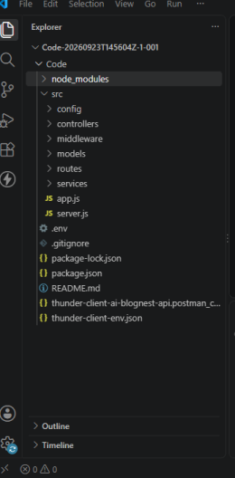
Figure 5: AI BlogNest API Project Structure in Visual Studio Code 10. BACKEND DEVELOPMENT
The backend provides REST APIs for authentication, blog management, comments, and AI-assisted content operations.
Authentication APIs
User Registration
User Login
JWT Authentication
Protected Routes
Blog APIs
Create Blog
Get All Blogs
Get Single Blog
Update Blog
Delete Blog
Comment APIs
Create Comment
Manage Comments
Comment Moderation
AI APIs
AI Blog Generation
Content Summarization
The AI BlogNest document specifically identifies AI generation and summarization endpoints. �
AI BlogNest API.docx
AI API Explanation
For each AI API, document:
Purpose:
Generate or summarize blog content using Google Gemini AI.
Request Structure:
The client sends a topic, prompt, or content through the API request. Response Structure:
The backend returns the AI-generated blog content or summary as a JSON response. Cost Considerations:
AI API usage may depend on the provider's usage limits and pricing. Security Practices:
The Gemini API key must be stored in environment variables and must not be exposed in source code.
server.js
AI controller/service
routes
Caption:
Figure 6: AI BlogNest Backend API Implementation
11. DATABASE DEVELOPMENT
MongoDB is used as the primary database for AI BlogNest.
Database Collections
Users
Posts
Comments
Categories
Analytics
Database Relationships
Users can create multiple posts.
Posts can contain multiple comments.
Users can create comments on posts.
Mongoose is used for schema definition, validation, and database interaction. Open MongoDB Compass and show:
Database
Collections
Documents
Caption:
Figure 7: AI BlogNest Database and Collections in MongoDB Compass Open the Posts collection and show one blog document. Caption:
Figure 8: Sample Blog Post Document in MongoDB
12. PROJECT EXECUTION
Step 1: Backend
Open the Server folder:
cd server
npm install
Step 2: Configure Environment Variables
Create:
.env
Example:
PORT=8000
MONGO_URI=your_mongodb_connection_string
JWT_SECRET=your_secret_key
GEMINI_API_KEY=your_gemini_api_key
Do not show the actual secret/API key in screenshots. Step 3: Run Backend
Use your actual project command, for example:
npm run dev
or:
nodemon server.js
Backend URL:
http://localhost:8000
Use the port actually shown by your server.
Server running...
MongoDB connected...
or whatever successful output your project actually displays. Caption:
Figure 9: AI BlogNest API Server Running Successfully 13. OUTPUT SCREENSHOTS WITH EXPLANATION API Testing
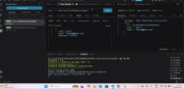
User Registration API
Show POST request + successful response.
Figure 10: User Registration API Testing
User Login API
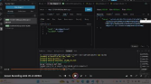
Show login request and JWT response.
Caption:
Figure 11: User Login and JWT Authentication
Create Blog API
Show blog creation request and response.
Figure 12: Create Blog API Testing
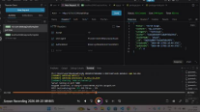
Get Blogs API
Show the list of blogs returned.
Caption:
Figure 13: Blog Retrieval API Testing
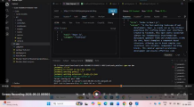
AI Blog Generation
Show the request/prompt and AI-generated blog response. Caption:
Figure 14: AI-Powered Blog Generation
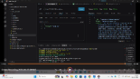
AI Summarization
Show the content sent and generated summary. Caption:
Figure 15: AI Content Summarization
PHOTO 16
MongoDB Output
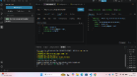
Show stored blog data in MongoDB Compass.
Caption:
Figure 16: Blog Data Stored in MongoDB
14. DEMO VIDEO LINK
Demo Video:
https://drive.google.com/file/d/1azakKjMU
dod1WJQs7bvbP1eoODnmHJi/view?usp=sharing
15. SOURCE CODE DRIVE LINK
Source Code:
https://drive.google.com/drive/folders/1S69VGxkcmkrsPhfJ6CE9af4Nf9WVnLsj?usp=sh aring
16. MANDATORY FUNCTIONALITIES
For your AI BlogNest API, list the functionalities that are actually implemented: MVC Architecture
JWT Authentication
Role-Based Access Control
MongoDB Database
REST API Development
Blog CRUD Operations
Comment Management
AI API Integration
AI Blog Content Generation
AI Content Summarization
Prompt Engineering,Input Validation,Input Sanitization,Secure Password Hashing

